Daniel Fryer
Assignment 7.2
2/20/2026

Step 2 results:
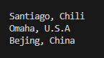
Step 3 results:
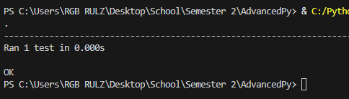
Step 5 results:
Cityfunciton:
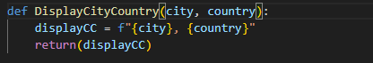
Test:
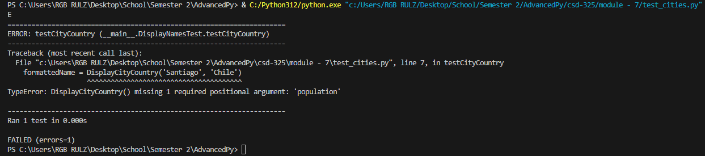

Step 7 results:
Cityfunctions:
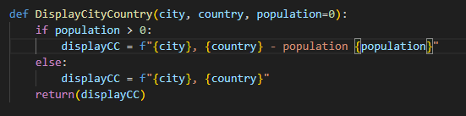
Test:
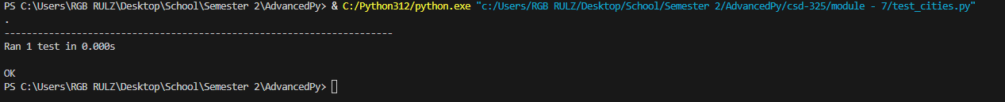
Step 9 results:
CityFunction:
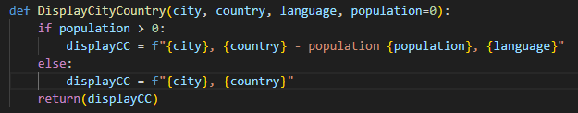
Test:
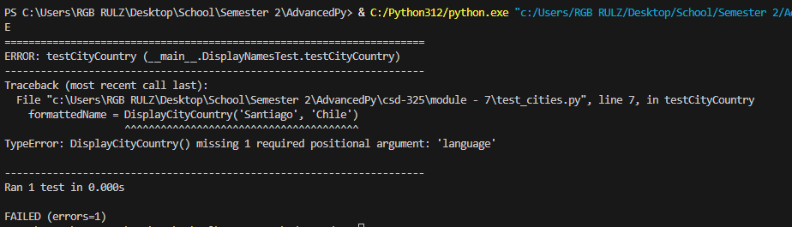
Step 12 results:
CityFunction:
